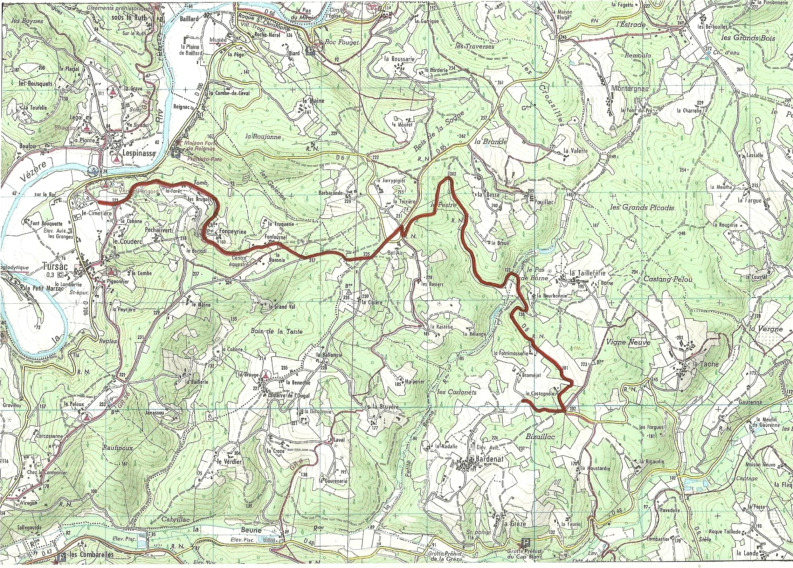
ES TURSAC

PLAN EMPLACEMENTS PUBLIC

ZONES EMPLACEMENT PUBLIC

ROUTES ACCES PUBLIC

ZONE 1
ZONE 2

